#
# 20200409
# Plan of works.
#
Phase Time Duration (min) Aсtion Group
21:30 5 Freeze VCS unix

22:55 5 Reconfigure VCS Oracle Home unix
22:55 5 Unfreeze VCS unix

https://wiki.tcsbank.ru/pages/viewpage.action?pageId=415273314

Upgrade базы EDA до 18-ой версии (Oracle)

ORACLE_BASE=/oramnt/EDA_prod_base
ORACLE_HOME=/oramnt/EDA_prod_oh18

Замораживаем базу. Если нет специальных указаний, то в режим “Temporary”.

На 3х нодах (ds-db25-prod1, ds-db25-prod2, m1-db25-dr):
mkdir /oramnt/EDA_prod_oh18
mkdir /oramnt/EDA_prod_base
chown oracle:oinstall /oramnt/EDA_prod_oh18
chown oracle:oinstall /oramnt/EDA_prod_base

mount -t nfs -o rw,bg,vers=3,tcp,timeo=600,rsize=65536,wsize=65536,hard,nolock a700-eda-prod-nfs:/EDA_prod_home/oh18 /oramnt/EDA_prod_oh18
mount -t nfs -o rw,bg,vers=3,tcp,timeo=600,rsize=65536,wsize=65536,hard,nolock a700-eda-prod-nfs:/EDA_prod_home/base /oramnt/EDA_prod_base

После маунта на 3х нодах (ds-db25-prod1, ds-db25-prod2, m1-db25-dr):
chown oracle:oinstall /oramnt/EDA_prod_oh18
chown oracle:oinstall /oramnt/EDA_prod_base

Ниже следующие команды запускаются с любой одной ноде.
hagrp -freeze OraEDA
haconf -makerw

hares -add mnt-EDA-oh18 Mount OraEDA
hares -modify mnt-EDA-oh18 MountPoint "/oramnt/EDA_prod_oh18"
hares -modify mnt-EDA-oh18 BlockDevice "a700-eda-prod-nfs:/EDA_prod_home/oh18"
hares -modify mnt-EDA-oh18 FSType nfs
hares -modify mnt-EDA-oh18 MountOpt "rw,bg,vers=3,tcp,timeo=600,rsize=65536,wsize=65536,hard,nolock"
hares -modify mnt-EDA-oh18 Critical 0
hares -modify mnt-EDA-oh18 Enabled 0

hares -add mnt-EDA-base Mount OraEDA
hares -modify mnt-EDA-base MountPoint "/oramnt/EDA_prod_base"
hares -modify mnt-EDA-base BlockDevice "a700-eda-prod-nfs:/EDA_prod_home/base"
hares -modify mnt-EDA-base FSType nfs
hares -modify mnt-EDA-base MountOpt "rw,bg,vers=3,tcp,timeo=600,rsize=65536,wsize=65536,hard,nolock"
hares -modify mnt-EDA-base Critical 0
hares -modify mnt-EDA-base Enabled 0

hares -link lsnr-EDA mnt-EDA-oh18
hares -link lsnr-EDA-dgr mnt-EDA-oh18
hares -link mnt-EDA-oh18 proxy-EDA-kNFS
hares -link ora-EDA mnt-EDA-oh18
hares -link GxClusterPlugin_OraEDA mnt-EDA-oh18

hares -link lsnr-EDA mnt-EDA-base
hares -link lsnr-EDA-dgr mnt-EDA-base
hares -link mnt-EDA-base proxy-EDA-kNFS
hares -link ora-EDA mnt-EDA-base
hares -link GxClusterPlugin_OraEDA mnt-EDA-base

hares -unlink lsnr-EDA mnt-EDA-orahome
hares -unlink lsnr-EDA-dgr mnt-EDA-orahome
hares -unlink mnt-EDA-orahome proxy-EDA-kNFS
hares -unlink ora-EDA mnt-EDA-orahome
hares -unlink GxClusterPlugin_OraEDA mnt-EDA-orahome

Меняем Home в листенерах (2шт) и oracle (1шт)
Меняем PFILE в Oracle /oramnt/EDA_prod_base/dbs/initEDA.ora и проверить наличие директории - файла может и не быть!

lsnr-EDA и lsnr-EDA-dgr - это название двх листенеров (2 шт.).
Home /oramnt/EDA_prod_oh18
TnsAdmin /oramnt/EDA_prod_oh18/network/admin/
ora-EDA - это название Oracle-чего-то (1 шт.).
Home /oramnt/EDA_prod_oh18
Pfile /oramnt/EDA_prod_oh18/dbs/initPG.ora

hares -modify lsnr-EDA Home /oramnt/EDA_prod_oh18
hares -modify lsnr-EDA TnsAdmin /oramnt/EDA_prod_oh18/network/admin/
hares -modify lsnr-EDA-dgr Home /oramnt/EDA_prod_oh18
hares -modify lsnr-EDA-dgr TnsAdmin /oramnt/EDA_prod_oh18/network/admin/
hares -modify ora-EDA Home /oramnt/EDA_prod_oh18
hares -modify ora-EDA Pfile /oramnt/EDA_prod_oh18/dbs/initPG.ora

Делаем Enabled + Critical на листенеры и oracle

hares -modify mnt-EDA-oh18 Enabled 1
hares -modify mnt-EDA-base Enabled 1

hares -modify mnt-EDA-oh18 Critical 1
hares -modify mnt-EDA-base Critical 1

УДАЛЯЕМ СТАРЫЙ HOME

hares -delete mnt-EDA-orahome

hacf -verify /etc/VRTSvcs/conf/config/ && haconf -dump -makero

Если необходимо

mount -t nfs -o ro,bg,vers=3,tcp,timeo=600,rsize=65536,wsize=65536,hard,nolock a700-eda-prod-nfs:/EDA_prod_home /oramnt/EDA_prod_base

Размораживаем базу

Белогруд Сергей:house_with_garden: 4:39 PM
А Freeze базы EDA делать Persistent?

Александров Алексей:slack_call: 4:40 PM
А написано какой? Вроде нет. Должно быть достаточно обычного. Persistent нужен для того чтобы сохранить статус заморозки после старта кластера.

Белогруд Сергей:house_with_garden: 4:26 PM
Привет!
По сегодняшним вечерним работам на VCS.
Где узнать на каких серверах живёт база EDA?

Александров Алексей:slack_call: 4:28 PM
Это 25-й кластер. Узнать где живет база можно зайдя по SSH на ее DNS имя db-eda-prod.tcsbank.ru. Для всех баз заведены такие имена. (edited)

[s.belogrud@TCS4357]# ssh bsv@db-eda-prod.tcsbank.ru
Warning: Permanently added 'db-eda-prod.tcsbank.ru' (RSA) to the list of known hosts.
Last login: Fri Jan 25 19:47:50 2019 from tcs4357.tcsbank.ru
[bsv@ds-db25-prod1 ~]$ exit
logout
Connection to db-eda-prod.tcsbank.ru closed.
[s.belogrud@TCS4357]#

From: Aleksandrov Aleksey Valerievich <a.v.aleksandrov@tinkoff.ru>
Sent: Thursday, April 9, 2020 4:00 PM
To: Rudik Dmitriy Aleksandrovich <d.rudik@tinkoff.ru>; Myalin Dmitriy <d.myalin@tinkoff.ru>; Belogrud Sergey Vladimirovich <s.belogrud@tinkoff.ru>
Cc: unix-admins <unix-admins@tinkoff.ru>; storage-admins <storage-admins@tinkoff.ru>; oradba <oradba@tinkoff.ru>
Subject: Re: [Oracle EDA обслуживание БД]

Инфа по миграции - https://wiki.tcsbank.ru/pages/viewpage.action?pageId=415273314

---
Алексей Александров

From: Rudik Dmitriy Aleksandrovich <d.rudik@tinkoff.ru>
Date: Thursday, 9 April 2020, 15:28
To: Myalin Dmitriy <d.myalin@tinkoff.ru>, Belogrud Sergey Vladimirovich <s.belogrud@tinkoff.ru>
Cc: unix-admins <unix-admins@tinkoff.ru>, storage-admins <storage-admins@tinkoff.ru>, oradba <oradba@tinkoff.ru>
Subject: Re: [Oracle EDA обслуживание БД]

Нужно будет переконфигурить в VCS (подробности у Леши Александрова)
Новые:
Oracle_home: /oramnt/EDA_prod_oh18
Oracle_base: /oramnt/EDA_prod_base

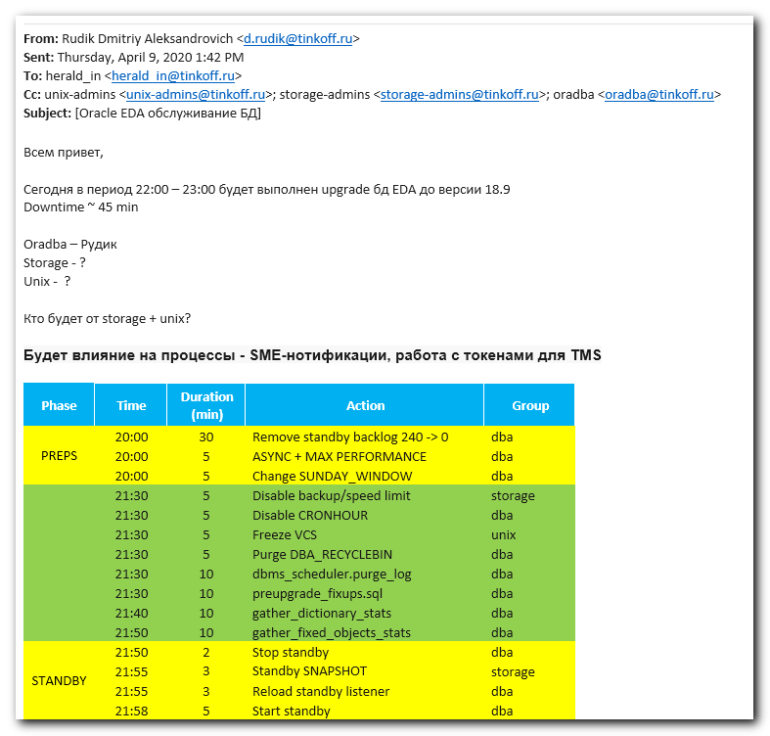
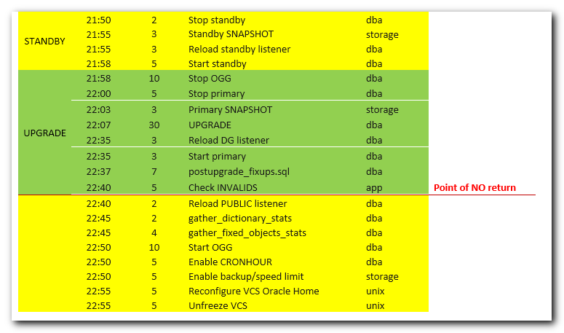

[s.belogrud@TCS4357]# ssh bsv@ds-db25-prod1
Last login: Thu Apr 9 16:37:20 2020 from tcs4357.tcsbank.ru
[bsv@ds-db25-prod1 ~]$ sudo -i
[sudo] password for bsv:
[22:49:07 root@ds-db25-prod1 ~]# mkdir /oramnt/EDA_prod_oh18
mkdir: cannot create directory ‘/oramnt/EDA_prod_oh18’: File exists
[22:50:29 root@ds-db25-prod1 ~]# mkdir /oramnt/EDA_prod_base
mkdir: cannot create directory ‘/oramnt/EDA_prod_base’: File exists
[22:50:29 root@ds-db25-prod1 ~]# chown oracle:oinstall /oramnt/EDA_prod_oh18
[22:50:29 root@ds-db25-prod1 ~]# chown oracle:oinstall /oramnt/EDA_prod_base
[22:50:29 root@ds-db25-prod1 ~]# mount -t nfs -o rw,bg,vers=3,tcp,timeo=600,rsize=6553 6,wsize=65536,hard,nolock a700-pg2-prod-nfs:/PG2_prod_home/oh18 /oramnt/EDA_prod_oh18
[22:51:19 root@ds-db25-prod1 ~]# mount -t nfs -o rw,bg,vers=3,tcp,timeo=600,rsize=6553 6,wsize=65536,hard,nolock a700-pg2-prod-nfs:/PG2_prod_home/base /oramnt/EDA_prod_base
[22:51:19 root@ds-db25-prod1 ~]#
[22:51:46 root@ds-db25-prod1 ~]# chown oracle:oinstall /oramnt/EDA_prod_oh18
[22:51:50 root@ds-db25-prod1 ~]# chown oracle:oinstall /oramnt/EDA_prod_base
[22:51:50 root@ds-db25-prod1 ~]# hagrp -freeze OraEDA
VCS WARNING V-16-1-40208 Group is already temporarily frozen
[22:52:25 root@ds-db25-prod1 ~]# haconf -makerw
[22:52:25 root@ds-db25-prod1 ~]#
[22:52:43 root@ds-db25-prod1 ~]# hares -add mnt-EDA-oh18 Mount OraEDA
VCS NOTICE V-16-1-10242 Resource added. Enabled attribute must be set before agent monitors
[22:52:47 root@ds-db25-prod1 ~]# hares -modify mnt-EDA-oh18 MountPoint "/oramnt/EDA_prod_oh18"
hares -modify mnt-EDA-oh18 FSType nfs
hares -modify mnt-EDA-oh18 MountOpt "rw,bg,vers=3,tcp,timeo=600,rsize=65536,wsize=65536,hard,nolock"
hares -modify mnt-EDA-oh18 Critical 0
hares -modify mnt-EDA-oh18 Enabled 0
[22:52:47 root@ds-db25-prod1 ~]# hares -modify mnt-EDA-oh18 BlockDevice "a700-eda-prod-nfs:/EDA_prod_home/oh18"
[22:52:47 root@ds-db25-prod1 ~]# hares -modify mnt-EDA-oh18 FSType nfs
[22:52:47 root@ds-db25-prod1 ~]# hares -modify mnt-EDA-oh18 MountOpt "rw,bg,vers=3,tcp,timeo=600,rsize=65536,wsize=65536,hard,nolock"
[22:52:47 root@ds-db25-prod1 ~]# hares -modify mnt-EDA-oh18 Critical 0
[22:52:47 root@ds-db25-prod1 ~]# hares -modify mnt-EDA-oh18 Enabled 0
[22:52:47 root@ds-db25-prod1 ~]#
[22:52:51 root@ds-db25-prod1 ~]# hares -add mnt-EDA-base Mount OraEDA
hares -modify mnt-EDA-base BlockDevice "a700-eda-prod-nfs:/EDA_prod_home/base"
hares -modify mnt-EDA-base FSType nfs
hares -modify mnt-EDA-base MountOpt "rw,bg,vers=3,tcp,timeo=600,rsize=65536,wsize=65536,hard,nolock"
hares -modify mnt-EDA-base Critical 0
hares -modify mnt-EDA-base Enabled 0
VCS NOTICE V-16-1-10242 Resource added. Enabled attribute must be set before agent monitors
[22:53:04 root@ds-db25-prod1 ~]# hares -modify mnt-EDA-base MountPoint "/oramnt/EDA_prod_base"
[22:53:04 root@ds-db25-prod1 ~]# hares -modify mnt-EDA-base BlockDevice "a700-eda-prod-nfs:/EDA_prod_home/base"
[22:53:04 root@ds-db25-prod1 ~]# hares -modify mnt-EDA-base FSType nfs
[22:53:04 root@ds-db25-prod1 ~]# hares -modify mnt-EDA-base MountOpt "rw,bg,vers=3,tcp,timeo=600,rsize=65536,wsize=65536,hard,nolock"
[22:53:04 root@ds-db25-prod1 ~]# hares -modify mnt-EDA-base Critical 0
[22:53:04 root@ds-db25-prod1 ~]# hares -modify mnt-EDA-base Enabled 0
[22:53:04 root@ds-db25-prod1 ~]#
[22:53:06 root@ds-db25-prod1 ~]# hares -link lsnr-EDA mnt-EDA-oh18
[22:53:20 root@ds-db25-prod1 ~]# hares -link lsnr-EDA-dgr mnt-EDA-oh18
[22:53:20 root@ds-db25-prod1 ~]# hares -link mnt-EDA-oh18 proxy-EDA-kNFS
VCS WARNING V-16-1-10249 Child resource does not exist: proxy-EDA-kNFS
[22:53:20 root@ds-db25-prod1 ~]# hares -link ora-EDA mnt-EDA-oh18
[22:53:20 root@ds-db25-prod1 ~]# hares -link GxClusterPlugin_OraEDA mnt-EDA-oh18
[22:53:20 root@ds-db25-prod1 ~]#
[22:53:30 root@ds-db25-prod1 ~]# hares -link lsnr-EDA mnt-EDA-base
[22:53:43 root@ds-db25-prod1 ~]# hares -link lsnr-EDA-dgr mnt-EDA-base
[22:53:43 root@ds-db25-prod1 ~]# hares -link mnt-EDA-base proxy-EDA-kNFS
VCS WARNING V-16-1-10249 Child resource does not exist: proxy-EDA-kNFS
[22:53:43 root@ds-db25-prod1 ~]# hares -link ora-EDA mnt-EDA-base
[22:53:44 root@ds-db25-prod1 ~]# hares -link GxClusterPlugin_OraEDA mnt-EDA-base
[22:53:44 root@ds-db25-prod1 ~]#
[22:53:46 root@ds-db25-prod1 ~]# hares -unlink lsnr-EDA mnt-EDA-orahome
[22:54:00 root@ds-db25-prod1 ~]# hares -unlink lsnr-EDA-dgr mnt-EDA-orahome
[22:54:00 root@ds-db25-prod1 ~]# hares -unlink mnt-EDA-orahome proxy-EDA-kNFS
VCS WARNING V-16-1-10249 Child resource does not exist: proxy-EDA-kNFS
[22:54:00 root@ds-db25-prod1 ~]# hares -unlink ora-EDA mnt-EDA-orahome
[22:54:00 root@ds-db25-prod1 ~]# hares -unlink GxClusterPlugin_OraEDA mnt-EDA-orahome
[22:54:00 root@ds-db25-prod1 ~]#
[22:54:01 root@ds-db25-prod1 ~]# hares -modify lsnr-EDA Home /oramnt/EDA_prod_oh18
hares -modify ora-EDA Home /oramnt/EDA_prod_oh18
hares -modify ora-EDA Pfile /oramnt/EDA_prod_oh18/dbs/initPG.ora
[22:54:18 root@ds-db25-prod1 ~]# hares -modify lsnr-EDA TnsAdmin /oramnt/EDA_prod_oh18/network/admin/
[22:54:18 root@ds-db25-prod1 ~]# hares -modify lsnr-EDA-dgr Home /oramnt/EDA_prod_oh18
[22:54:18 root@ds-db25-prod1 ~]# hares -modify lsnr-EDA-dgr TnsAdmin /oramnt/EDA_prod_oh18/network/admin/
[22:54:18 root@ds-db25-prod1 ~]# hares -modify ora-EDA Home /oramnt/EDA_prod_oh18
[22:54:18 root@ds-db25-prod1 ~]# hares -modify ora-EDA Pfile /oramnt/EDA_prod_oh18/dbs/initPG.ora
[22:54:18 root@ds-db25-prod1 ~]#
[22:54:20 root@ds-db25-prod1 ~]# hares -modify mnt-EDA-oh18 Enabled 1
[22:54:36 root@ds-db25-prod1 ~]# hares -modify mnt-EDA-base Enabled 1
[22:54:36 root@ds-db25-prod1 ~]#
[22:54:37 root@ds-db25-prod1 ~]# hares -modify mnt-EDA-oh18 Critical 1
[22:54:47 root@ds-db25-prod1 ~]# hares -modify mnt-EDA-base Critical 1
[22:54:47 root@ds-db25-prod1 ~]#
[22:54:49 root@ds-db25-prod1 ~]# hares -delete mnt-EDA-orahome
[22:55:01 root@ds-db25-prod1 ~]#
[22:55:02 root@ds-db25-prod1 ~]# hacf -verify /etc/VRTSvcs/conf/config/ && haconf -dump -makero
[22:55:15 root@ds-db25-prod1 ~]#
[22:55:16 root@ds-db25-prod1 ~]#

# After applying all commands. The picture was this.
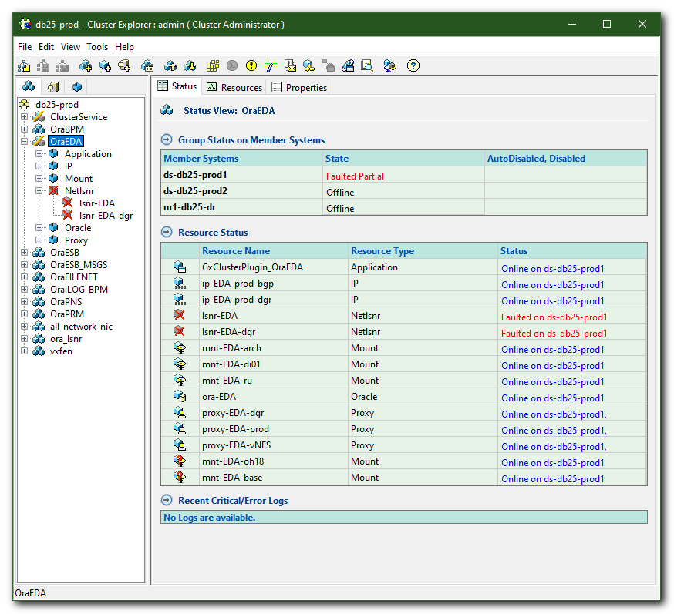

# After 10-20-30 seconds the picture becomes like follow.
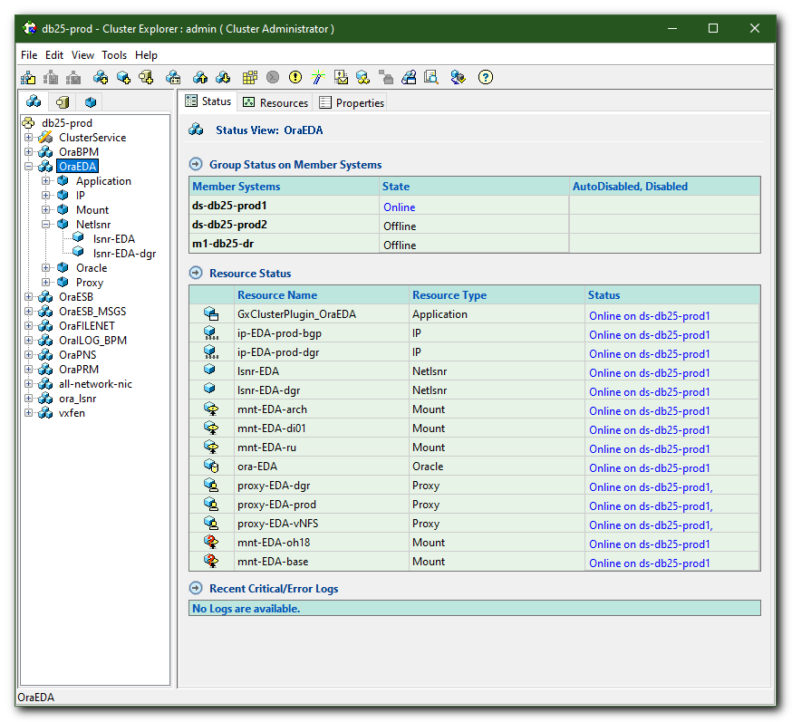

# And here are two errors.
# The database was not started.
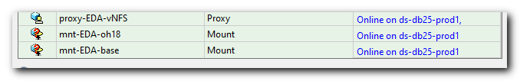
# The root of mistakes was here. Wrong name of resources. PG2 have to be changed to EDA.
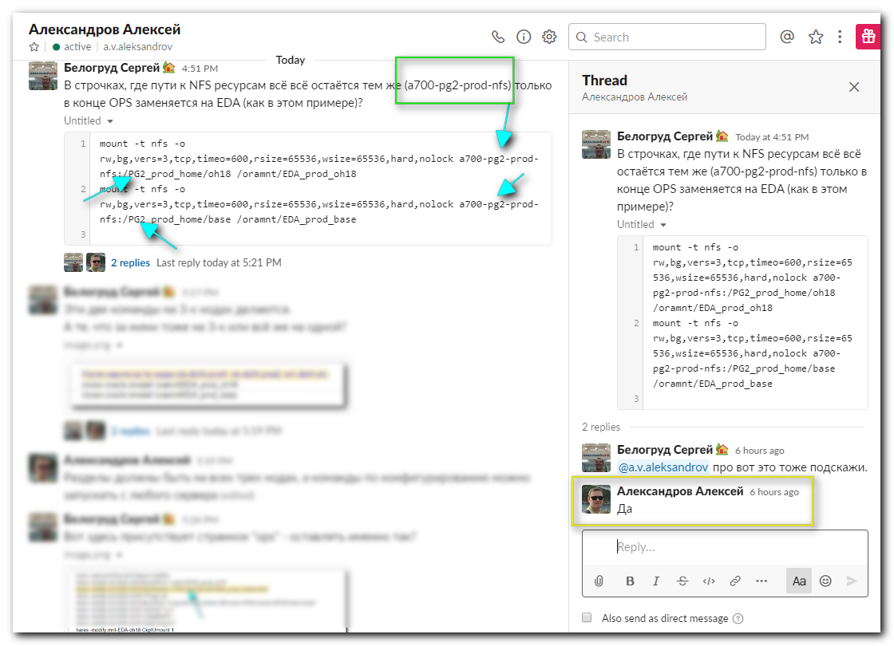
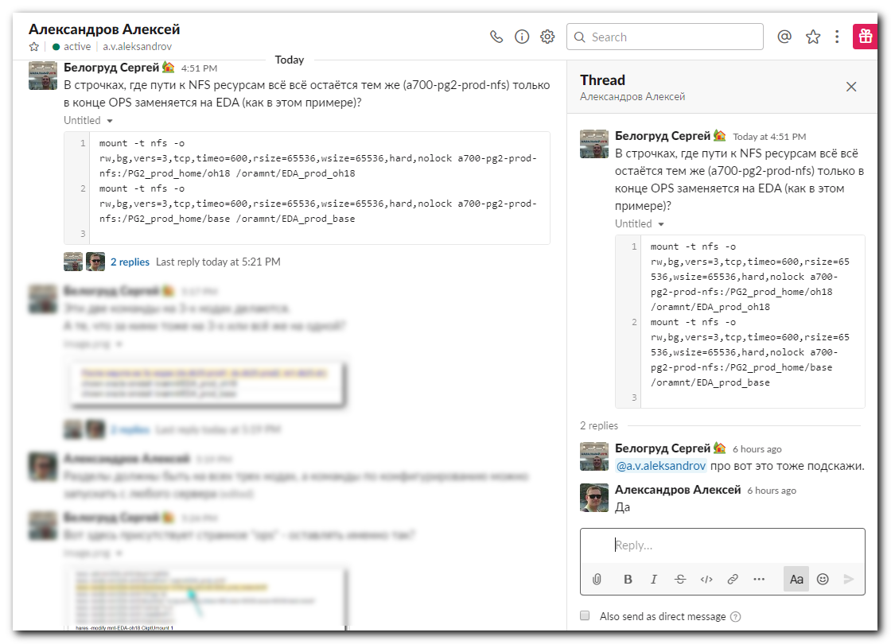

# After Aleksandrov Aleksey fixed this problem.
